C# Exercises

## I. [Console Input/Output](https://msdn.microsoft.com/en-us/library/system.console(v=vs.110).aspx)

1. Write “**What is your name?** ” to the console. From the same line, read a name from the console and on the next line write in red a message “Hello <name>. Welcome to America!”.

Hints: Console.Write, Console.ReadLine, Console.ForegroundColor, String.Concat or [string interpolation](https://docs.microsoft.com/en-us/dotnet/csharp/language-reference/keywords/interpolated-strings).

Project Name: WhatsYourName

2. Write “**Enter a number:** “ to the console. Read the user input from the console. If the value entered is a number, write to the console “Excellent number!” in green. Otherwise write in red “That’s not a number!”.

Hints: Console.Write, Console.ReadLine, [double.TryParse](https://msdn.microsoft.com/en-us/library/994c0zb1(v=vs.110).aspx), Console.ForegroundColor

Project Name: EnterANumber

3. Write a line to the console “**Enter numbers, or a blank line to continue.**”. In a loop, prompt the user with “**Next number:** “, and read lines from the console until a blank line is entered. Then calculate the average (mean) of all of the numbers entered and output “**You entered <N> numbers. Their mean value is <mean>.**” The mean should be output with 2 decimal places. If an invalid number is entered, the loop should continue. If 0 numbers are entered, output should be “**Mean cannot be calculated.**”.

Hints: Console.WriteLine, Console.Write, Console.ReadLine, [while loop](https://docs.microsoft.com/en-us/dotnet/csharp/language-reference/keywords/while), [double.TryParse](https://msdn.microsoft.com/en-us/library/994c0zb1(v=vs.110).aspx), string.Length, [string interpolation](https://docs.microsoft.com/en-us/dotnet/csharp/language-reference/keywords/interpolated-strings)

Project Name: NextNumberPlease

4. Write a prompt to the screen “**Enter a sentence:** “. Read the user’s input and echo it to the screen with the order of the words reversed. Then prompt “**Enter another sentence:** “, read that input and echo it with words reversed. Continue doing this in a loop until the user enters nothing. Note that the order of the characters within the words must not be reversed.

Sample Input: The quick brown fox jumped over the lazy dog.

Sample Output: dog. lazy the over jumped fox brown quick The

Hints: [string.Split](https://msdn.microsoft.com/en-us/library/system.string.split(v=vs.110).aspx), [Array.Reverse](https://msdn.microsoft.com/en-us/library/d3877932(v=vs.110).aspx), [string.Join](https://msdn.microsoft.com/en-us/library/system.string.join(v=vs.110).aspx)

Project Name: EnterASentence

5. Write a prompt to the console “**Enter a character:** “. Read a single character from the console, then fill the entire screen with that character. The characters should alternate in color red/cyan. Choose any background color that provides a pleasant contrast.

Hints: Console.ReadKey, Console.WindowWidth, Console.WindowHeight, Console.SetCursorPosition, Console.ForegroundColor, Console.BackgroundColor

Project Name: Dots

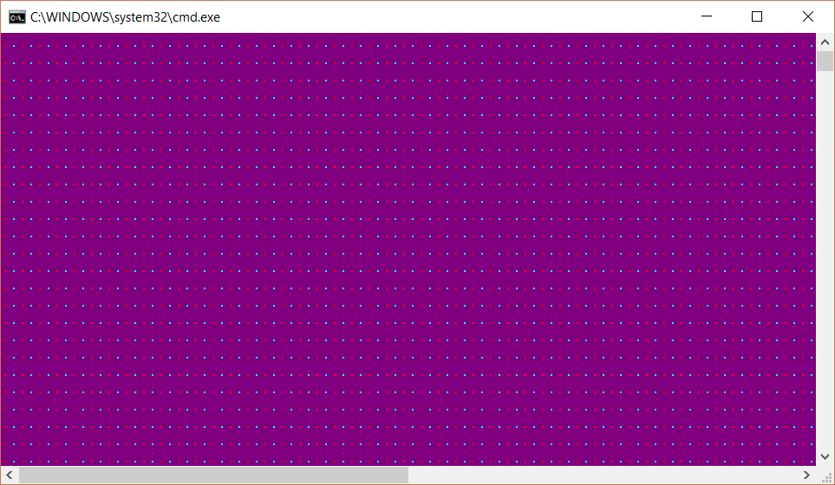

6. Write to the console “**Hello. What is your name?**”. Read a name from the console. Then clear the console and write in the center of the console “**Hello <name>!**”. The output should be framed in asterisks (*) with a margin of 1 space around the name. Use Cyan for the foreground, DarkBlue for the background.

Hints: Console.Clear, Console.WindowWidth, Console.WindowHeight, Console.SetCursorPosition, [new string(char, count)](https://msdn.microsoft.com/en-us/library/xsa4321w(v=vs.110).aspx)

Project Name: FrameName

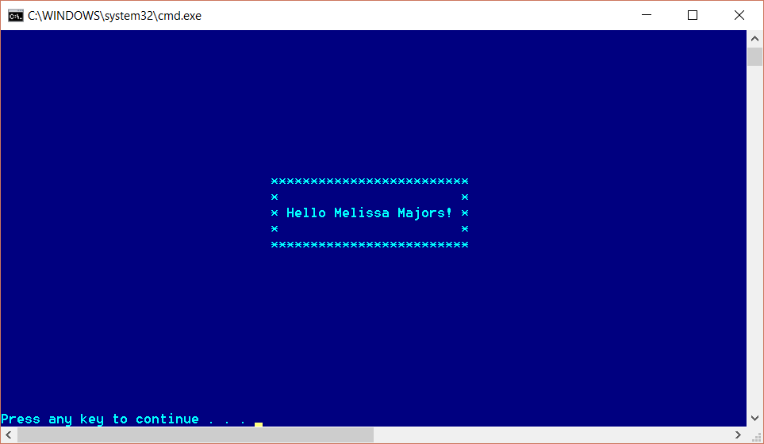

## II. [Strings](https://msdn.microsoft.com/en-us/library/system.string(v=vs.110).aspx) & [Characters](https://msdn.microsoft.com/en-us/library/system.char(v=vs.110).aspx)

1. Prompt the user to “**Enter a string containing dashes:** “ and read that input from the Console. Given an input string in the format “abc-def-ghi-jkl-mno”, output a string “mno^jkl^ghi^def^abc”. In the example, a, b, c, d, etc. can be any character except for dash. The algorithm should also work with strings with variable length sections and numbers of sections, such as “abcd-ef-ghijkl-mn”, which would give an output of “mn^ghijkl^ef^abcd”.

Hints: [string.Split](https://msdn.microsoft.com/en-us/library/system.string.split(v=vs.110).aspx), [Array.Reverse](https://msdn.microsoft.com/en-us/library/d3877932(v=vs.110).aspx), [string.Join](https://msdn.microsoft.com/en-us/library/system.string.join(v=vs.110).aspx)

Project Name: Dashes2Carets

2. Prompt the user to “**Enter a string:** “, then read that string. Next ask the user to “**Enter a number:** “ and read that number. If the number parses, output the character at that position in the string. The position is zero-based, meaning that 0 would return the first character of the string. If the number is beyond the length of the string, the output should be “**Index is out of range**”.

Example Input: supercalifragilistic 12

Example Output: g

Hints: [int.TryParse](https://msdn.microsoft.com/en-us/library/system.int32.tryparse(v=vs.110).aspx), String.Length, string[]

Project Name: CharacterAt

3. Prompt the user “**Enter some text:** “. Read the text and count the # of characters in the string which are:

a) letters

b) digits

c) punctuation

d) other

Output should be “nl nd np no” where nl, nd, np and no are the respective counts.

Example Input: Winter Storm Watch in effect from February 17, 07:00 PM EST until February 18, 07:00 AM EST

Example Output: 59 12 4 16

Hints: [foreach](https://docs.microsoft.com/en-us/dotnet/csharp/language-reference/keywords/foreach-in), static methods of the [Char struct](https://msdn.microsoft.com/en-us/library/system.char(v=vs.110).aspx).

Project Name: CountCharacters

4. Prompt the user “**Enter first string:** ”, then read that string from the console. Prompt the user “**Enter second string:** “ and read the second string. For every character of the second string, replace all occurrences of the character in the first string with a 0 (zero).

Example Inputs: “Sunrise is an exceptionally beautiful time of day” “respect”

Example Output: “Sun0i00 i0 an 0x0000ionally b0au0iful 0im0 of day”

Hints: [StringBuilder](https://docs.microsoft.com/en-us/dotnet/api/system.text.stringbuilder?view=netframework-4.7.1)

Project Name: CharSwap

## III. Files

1. Given a modest-sized text file “Prufrock.txt”, make a list of each of the words found in the file and count how many times they occur. Word comparisons should be case-insensitive – for example, “Upon”, and “upon” are the same word. Exclude words of length 3 or less. Sort the list by word-count decreasing and output the top 10 words and counts.

Characters considered as punctuation are pre-defined above the main method.

Hints: [File.ReadAllText](https://docs.microsoft.com/en-us/dotnet/api/system.io.file.readalltext?view=netframework-4.7.1), String.Split, [Dictionary<string,int>](https://docs.microsoft.com/en-us/dotnet/api/system.collections.generic.dictionary-2?view=netframework-4.7.1)

Project Name: Prufrock

2. Given a huge text file “MobyDick.txt”, count words as in the previous exercise with the following differences: a) count only words of 6 or more characters; b) do not read the entire file into memory; c) output the top 50 words.

Hints: [StreamReader](https://docs.microsoft.com/en-us/dotnet/api/system.io.streamreader?view=netframework-4.7.1) or [File.ReadLines](https://docs.microsoft.com/en-us/dotnet/api/system.io.file.readlines)

Project Name: MobyDick

3. Given a binary file “numbers.bin” that contains an unknown number of double values, read all of the numbers and compute their mean value. Write the mean value to the console as a message “The mean of N values is nn.nn” where N is the number of values read and nn.nn is the mean (using 2 decimal places).

Hints: [BinaryReader](https://docs.microsoft.com/en-us/dotnet/api/system.io.binaryreader?view=netframework-4.7.1).ReadDouble, BinaryReader.BaseStream, [Stream](https://docs.microsoft.com/en-us/dotnet/api/system.io.stream?view=netframework-4.7.1).Position, Stream.Length

Project Name: ReadNumbers